12.01
Financial accounting
Process Design & AMOS Configuration Document
Purpose
This Process Design document is provided to Key-Users to record their key decisions regarding the AMOS Process design and the required AMOS configuration.
It is updated throughout the Project Definition Phase and used as the baseline for the Final Acceptance prior to Go-Live
Revision
Author, Name | Date | Notes
Hamid Ouazi | 01.06.2024 | First Version

Table of Contents
1. Process Overview & Objectives 3
2. Regulatory References 3
3. Definitions & Glossary 3
4. Process Tasks 4
5. Process Dependencies 5
6. Process Flow 6
7. Process Design Questions 7
8. Data Source Mapping 10
9. Other Software Used 10
10. AMOS Configuration 11
a. Process specific configuration programmes 11
b. Basic Data 11
c. Parameters 12
d. Workflows 13
e. Scheduled Tasks 14
f. API’s & Interfaces 15
11. UAT Guidance 15
12. Annex – Additional Info 15

Process Overview & Objectives

Process General Description:
This process describes how AMOS creates General Ledger bookings/postings based on financial relevant transactions performed by an AMOS user. These transactions are related to part movements such as consumptions (pick slip requests), goods receiving, material scraps, material and service sales, book of services, inventory adjustments, part attributes changes (material class, material type, fixed asset flag etc.).
Main Process Objective (Outputs & Outcomes):
This process has 2 main objectives as outputs:
- Generate double entry bookings in the General Ledger Monitoring System (APN1715)
- Verify the validity and reliability of the financial data.

Regulatory References
- Accounting principles
- IFRS
- GAAP
- IAS 2 and IAS 16

Definitions & Glossary
Concerns doc & flowchart
Keywords | Explanation
IAS | International accounting standards (IAS2 related to inventory accounting principles and IAS16 related to Property Plan and Equipment (fixed assets) accounting principles)
IFRS | International Financial Reporting Standards
GAAP | Generally Accepted Accounting Principles
GL | General Ledger
CoA | Chart Of Account
FOC | Free Of Charge
Inventory / stock | It’s a part that is consider in a specific asset account (current) which  is a stock account and it is valuated at the average price / actual costs and its consumptions are also valuated at the average price / actual costs.
Cost Center | A part of an organization to which costs may be charged for accounting purposes. It is an additional dimension for cost assignment and analysis. Usually, they are divided into organic and non-organic. The organic cost center can be the department structure and the non-organic cost center can be line of production, business units, other.
FA | Financial type. It is another dimension in AMOS that can be useful for cost analysis. It is possible to assign each part number to a financial type in part administration (APN59). The table of financial types is defined in Basic Data table (APN18).
Financial Quantity | It is the quantity of parts that are owned by a company and are considered for the calculation of the financial stock value. It is not relevant whether they are or not located physically in a company’s store (even for parts sent to a customer under a customer loan which are not physically located in the company store, since the same still belong to the company and will return).
Physical Quantity | It is the quantity of parts physically located in AMOS stores, no matter the ownership. Can be owned or foreign parts.
AIM | Adaptive Integration Manager – program related to interface management and setup
FSV | Financial Stock Valuation

Process Tasks

Business Process Task / Actions / Activities:
- Define chart of accounts, cost centers, financial transactions (see paragraph 10. Process Configuration)
- Define inventory stock policy: the purpose is to define the financial stock valuation method (Perpetual Average Price, Periodical Average Price, Actual Costs)
- Update foreign currency exchange rates: Can be done manually or by means of automated interface at desired frequency.
- Monitor and Control accounting for inventory rotable parts & tools: automatically generated by AMOS in the GL
- Monitor and Control accounting for inventory consumable- & expendable parts & tools: automatically generated by AMOS in the GL
- Monitor and Control accounting for low value tools (and/or parts): automatically generated by AMOS in the GL
- Monitor and Control accrual cost accounting: automatically generated by AMOS in the GL
- Monitor and Control accounting for fixed assets, capital improvements and embedded maintenance.
- Perform month-end reconciliation, validation and closing: analyse GRNI report, Financial stock value and physical stock value. Perform reconciliation with the Finance ERP system.
- Perform consistency Analysis.
- Review part’s price data: check/correct the average price / actual costs for a dedicated serial number.
- Monitor the label booking in the Booking Analyser:
  - Edit single labels.
  - Match & Close single labels
  - Swap owners of matched labels

Process Dependencies

INPUTS: All the material movements trigger financial transactions and generate accounting postings in the GL of AMOS.
INPUT | CONCURRENT | OUTPUT
- 02.02 Aircraft Phase-out  - 08.04 Parts Removal & Installation  - 09.03 Ordering  - 09.04 Repair & Exchanges  - 09.06 Pooling & Consignment  - 10.02 Good Receiving & Inspection  - 10.04 Part request Fulfilment  - 10.06 Inventory & Shelf-Life Control  - 12.02 Invoice Checking  - 12.03 Fixed Assets & Depreciation  - 12.07 Financial Multi-entity | - N/A | - Transfer General Ledger Interface

Process Flow
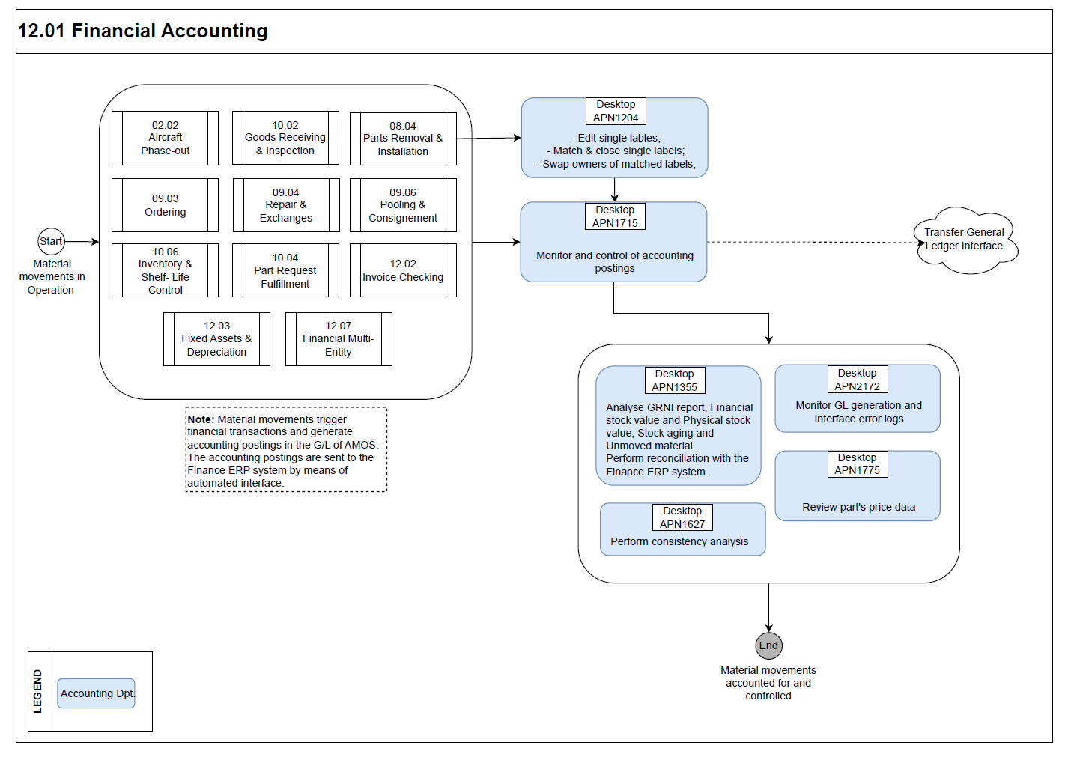

Process Design Questions

# | Question | Answer
1 | What is the way to build the Account Number tree?
2 | Are chart of accounts and account code the same in all entities or are they different?
3 | How is the cost center structure defined? One per A/C reg.? One per Station/Store/Department/Shop? Should they be mandatory on orders and invoices?
4 | How are the cost types defined? Where are they to be used – MODs, Orders, invoice charges?
5 | What is the accrual process? How do you do accruals? Consider the use of Financial Reports (APN: 1355) “GR/IR (Good Receipt / Invoice receipt)” / It is also possible to extract from APN307 INVOICE CHECKING a report with the open/new invoices
6 | Do you also accrue for non-received orders? Consider the use of financial reports (APN: 1355) “ Value On Open Orders” / The APN 1328 Order Tracking can also deliver valuable information for this process.
7 | Do you do Revenue Accruals? What method do you use to calculate the revenue to be accrued?
8 | Do you defer cost/revenue?
9 | How are A/C or component lease costs handled? And the maintenance reserves?
10 | How are Services Orders handled?
11 | How are Repair & Exchange Orders costs handled?
12 | Are you considering Rotables as Fixed Assets or Inventory item?
12 | How are Consumables (stock) and Rotables (Fixed Assets) Purchase Orders handled?
13 | What should affect the average price of stock parts? FOC receiving? Currency variations? Freight costs? Other?
14 | How do you handle currency variations? Should they affect average price of the part or not (in which case FX differences will be booked on a currency variations account)?
15 | How do you handle Free of Charge items for consumables (stock)? Should they affect average price or be booked on a revenue account? And if they are Fixed Assets, which data should be sent to the ERP system?
16 | How do you handle additional charges? Freight, bank charges, handling charges, dangerous goods, third party transportation invoices etc.
17 | Where will fixed assets be depreciated – in AMOS or in the ERP system (or both)? Will the Depreciation module be used?
18 | What is the accounting treatment of CAPEX projects, such as Aircraft Modifications and Heavy checks or Component Modifications and overhauls? Are these costs capitalized and depreciated over time? Would this happen in AMOS?
19 | After reviewing the standard Financial Transactions in AMOS, which are the ones that you will use (do they need to be modified or not?) and the new ones that need to be created?
20 | What are the part attributes and rules that will be configured in Part Administration to categorize parts in categories such as Stock, Fixed Assets, Tool, Services (See material class and material type tables)
21 | What are the common accounting errors? Cost center not filled, wrong cost centers, wrong project, wrong part classification, wrong or not filled GL account and/or vendor account… check parameters and workflows available to prevent these errors from happening.
22 | Who is allowed to modify material type, material class, tool flag and fixed asset flag in part admin as well as the average price (or the actual costs)? Should somebody be informed if such charges happen?
23 | Which Financial ERP system do you need to integrate the data to? SAP, Oracle, MS Dynamics, Navision, Sage? Other? Is there any middleware to be used?
24 | Who will be responsible to monitor the Logs of Scheduler tasks and interfaces and correct the errors?
25 | What is the stock valuation method used in your entity?
26 | When does your financial year start? Set param 951
27 | Do you have part numbers with an average price or actual costs = 0?
28 | How are stock provisions handled? What are the stock ageing accounting and analysis procedures?
29 | Do you want to consider and export to the financial system the 0 amount GL Bookings?
30 | Would you like to use Repairable-Consumable logic? How do you valuate your consumable repairable parts?
31 | Will you use the concept of multi entity? If yes, is there an owner under each entity to be considered? What addresses will be considered as Entity and Owner in AMOS?

Data Source Mapping

Data Sources | Description | Volume / Manual / Automatic / Static / Dynamic
 | -/- | -/-

Other Software Used

Other Softwares | Used by: | Description
-/- | -/- | -/-

AMOS Configuration

Process specific configuration programmes
AMOS APN | Notes
1940 – Financial Entity Administration | The entry point for the financial configuration is the setup of the single or multi financial entities. Here, the user is going to configure the entity address (coming from the address APN53), entity owner, the functional (not mandatory) and the local entity currency (coming from the currency management APN355)
59 – Part Administration | The creation/modification/classification of the part in AMOS have significant financial impacts. The following part’s attributes have financial impacts especially when one of those attributes change: the material class, material type, FA Type, fixed asset flag, tool flag, repairable flag. Those attributes are relevant to setup the financial transactions in the APN1658.
1664 – Chart of Accounts | Usually, the CoA numbers are the same as the financial ERP. The user defines the CoA within the pre-defined structure proposed by AMOS and generated automatically after importing the default financial transaction in APN1658.
1658 – Financial Transaction Definition | Each financial-relevant transaction/movement in AMOS is identified by a code, called voucher mode (VM). Voucher modes are transaction-specific, e.g. B1 = Receiving of Material, YE = Rotable removal from aircraft, and thus, can be used to define each financial transaction’s logic. Complete list of voucher modes may be found in Basic-Data Administration (APN:18)- ‘Voucher Mode’ table.
781 – Define FA Qty calculation | Each company has internal regulations and processes describing the criteria that need to be fulfilled if the parts should be counted in its financial quantity. In AMOS this is configured in Define FA Qty Calculation (APN:781) program.  The Financial Quantity is the quantity of material that is used for calculation of the Financial Stock Value.
2365 – Financial Configuration | See bellow in the Parameter paragraph b.

Basic Data

Basic Data Table | Notes
Cost Center | Recommendation: use the same code as the Financial System
Cost type
Material Type
Project Type
FA_Type | Recommendation: use the same code as the Financial System
Material Class
Specials Contract | Usually used to define Fixed asset groups/categories
Fixed Asset type

Parameters

Parameter Code | Parameter Name | Notes
1569 | DEFAULT FINANCIAL ENTITY
980 | FIELD OWNER IN PRG. REC-GOODS | Integer: 2
1604 | CURRENCY IN ENTITY TRANSACTION MANAGEMENT
1617 | Entity Transaction Billing Mode
1627 | PRICE FOR ROTABLES IN ETM
1628 | PRICE FOR CONSUMABLES IN ETM
1514 | ACTIVATE RULE-BASED GENERAL LEDGER | String = YES
1562 | GENERAL LEDGER DYNAMIC | String = YES
875 | AMOS OPERATOR CODE
950 | FINANCIAL QTY CALCULATION | To be setup in Define FA Qty Calculation APN: 781
951 | START OF FINANCIAL PERIOD
976 | DISABLE REAL TIME FA-QTY CALCULATION
1153 | LABEL: CREATE ADJUSTMENT BOOKINGS | Voucher Modes AJ / SJ
1432 | FREE OF CHARGE SETTINGS
1471 | ENSURE FINANCIAL CONSISTENCY
1481 | FA COUNTERPART LOGIC ACTIVE
1487 | ACTIVATE LABEL SINGLE BOOKING LOGIC
1517 | START OF FINANCIAL YEAR | Invoice checking / Depreciation
1532 | CHOSEN CALCULATION METHOD | Average price calculation method
1603 | Validate Single Booking Compensation
1563 | CURRENCY RATE CHANGE IMPACT ON MOVING AVERAGE PRICE | Does currency rate change between receiving goods and invoice checking impact the moving avg. price?
1564 | MOVING AVERAGE PRICE TOLERANCE | Tolerance of the moving average price change.
1568 | AV. PRICE INITIALIZATION FOR EXISTING STOCK
1574 | EXTERNAL PURCHASE RECEIVING SURCHARGE MARKUP | Only for moving average price method. Percentage of the surcharge markup calculated on the received purchase price.
1601 | Activate the Functional Average Price
1607 | PRICE REEVALUATION TRANSACTIONS PROCESS | Only for Periodic Average Price Method
1669 | Activate Buyer Furnished Equipment impact on stock valuation | Decide if BF order invoice checking should have an impact on existing stock value by changing the part average cost
1449 | FINANCIAL CORRECTION BOOKINGS ACTIVE
1395 | TURN AIM LOGGING ON/OFF
1709 | Consider invoice bookings in consistency | Set to: YES
1940 | Activate Actual Cost Valuation for Rotables | Only in case rotable are considered as Inventory items. The system is going to valuate the item on its Serial Number Level

Workflows

Workflow Number | Workflow Name | Workflow Setup Notes
235 | General Ledger Build Service Problem | This workflow is triggered when the General Ledger build service is called and something unusual happens. To be able to monitor the error log of the scheduler tasks, we recommend to setup this workflow and also workflow 12 to send an email every time there is an error in the task.
303 | Matching Of Single Bookings | This Workflow will be triggered by the Rotables Label Booking and the Component Tree Label Booking, when a single label booking is performed.
304 | Owners Swapping on Label Bookings | This Workflow will be triggered by the Rotables Label Booking and the Component Tree Label Booking, when a single label booking is matched or a full label is performed. The Owners Swap happens automatically when this workflow is active.
404 | Depreciation Swap on Label Bookings | Swap of Serial numbers under depreciation. This Workflow will be triggered when two single label bookings are matched or a full label is performed, if on- and off- rotables belong to the same entity and one of them is under active depreciation.
431 | AMOSmobile Matching Of Single Bookings | AMOSmobile only: This Workflow will be triggered by Book Component Change, when a single label booking is performed.
432 | AMOSmobile Owners Swapping on Label Bookings | AMOSmobile only: This Workflow will be triggered by Book Component Change, when a single label booking is matched or a full label is performed. The Owners Swap happens automatically when this workflow is active.
434 | AMOSmobile Depreciation Swap on Label Bookings | AMOSmobile only: This Workflow will be triggered when two single label bookings are matched or a full label booking is performed. The Depreciation Swap can happen only when all of the following criteria are fulfilled: - Depreciations are Active in AMOS (Parameter 1501) - Both involved Rotables belongs to the same Financial Entity - One of the Rotable is on a running Depreciation To abort Depreciation Swap you have to set the conditions that lead to a Condition Abort Action. Note: If an Owners Swap is executed, the existing Depreciation(s) will be automatically swapped.
115 | Put part on pickslip | This workflow may be used to control accessibility of parts on projects in Pickslip confirmation. For instance, if a part is exclusively bought for a project, then it should not be allowed to pickslip it for another project. Use conditions part_projectno <> pickslip_projectno
149 | AIM Export has completed | Setup workflow to monitor the errors of the interfaces. Use wildcard condition Status = - 100 to report only in case of errors.
97 | AIM Logging Notification
249 | AIM Import has completed
12 | Scheduler Task Message

Scheduled Tasks

Scheduled Task Reference | Frequency | Notes
PartFAEntityInitialization | run ONCE when an entity is created for the first time
FinancialPerpetualMovingAveragePriceActivation | run ONCE to activate the use of the Perpetual Moving Average Price | Param 1532
FinancialFsvBasedAveragePriceActivationTask | run ONCE to activate the use of the Financial Stock Value Based Moving Average Price | Param 1532
FinancialFsvRoundingTask
FinancialSanityCheck
InitializeAddressEntityAccounting | run ONCE only if parameter 1595 ENTITY RELATED ACCOUNTING is activated | Param 1595
FunctionalPriceInitializationTask | run ONCE only if parameter 1601 Activate the Functional Average Price is activated | Param 1601
GeneralLedgerExportTask | Daily
FinancialSnapshotCreationTask | Monthly and weekly
FinancialConsistencyCheckService | Monthly and weekly – run after FinancialSnapshotCreationTask
CalculateFaQtyService | Minimum daily
FinancialPeriodClosingTask | Monthly for Periodic avg. price; Yearly for Moving avg. price
FinancialActualCostActivationTask | Run it once after activation of param 1940 Actual Cost valuation

API’s & Interfaces

Reference | Direction | Trigger | Frequency
TRANSFER GENERAL LEDGER | OUT |  | (usually daily)

UAT Guidance

Note: For the UAT, the best way to test all the financial data, financial impacts (GL, financial reports etc.), financial configurations, CoA, financial transactions… is to use the following Test Scenario file and run the different test-cases.

Annex – Additional Info
-/-

